**Find a country based on country code**

**Step-1:** Created new exception class CountryNotFoundException in com.cognizant.spring-learn.service.exception

**CountryNotFoundException.java**

**package** com.cognizant.orm_learn.service.exception;

**public** **class** CountryNotFoundException **extends** Exception {

**public** CountryNotFoundException(String message) {

**super**(message);

}

}

**Step-2**:Created new method findCountryByCode() in CountryService with @Transactional annotation

**@Transactional**

**public** Country findCountryByCode(String code) **throws** CountryNotFoundException {

Optional<Country> result = countryRepository.findById(code);

**if** (!result.isPresent()) {

**throw** **new** CountryNotFoundException("Country with code " + code + " not found.");

}

**return** result.get();

}

**Step-3:** Added test log statements to OrmLearnApplication.java

**private** **static** **void** testGetAllCountries() **throws** CountryNotFoundException {

***LOGGER***.info("Start");

Country country = *countryService*.findCountryByCode("IN");

***LOGGER***.debug("Country:{}", country);

***LOGGER***.info("End");

}

**Output:**

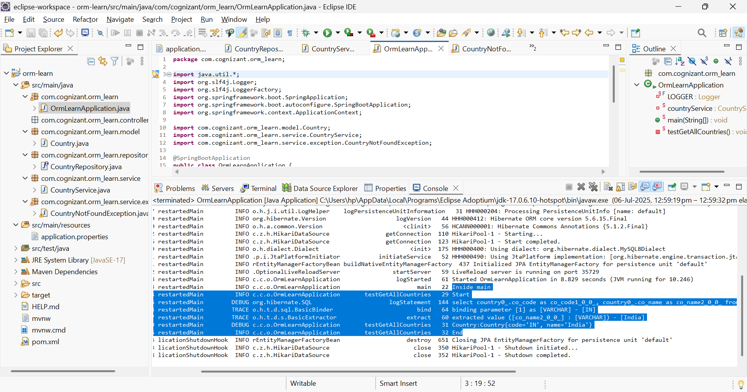

Passed [IN] var and only India is printed